PINNACLE BANK: Comprehensive System Documentation & Technical Blueprint
1. Introduction & Executive Summary
PINNACLE BANK is an enterprise-grade, secure digital banking platform built as a high-performance single-page application (SPA). Engineered to bridge the gap between retail banking convenience and institutional security, the system delivers an intuitive, feature-rich financial management workspace.
The platform empowers account holders, business operators, and financial administrators to perform day-to-day banking operations—such as multi-account balance monitoring, peer-to-peer fund transfers, card security management, and historical transaction auditing—without the latency and friction typical of legacy financial portals.
2. Problem Statement & Strategic Justification
Traditional banking infrastructures and legacy consumer portals face persistent systemic challenges that degrade user experience and operational efficiency:
- Convoluted Navigation Hierarchies: Legacy online banking applications frequently bury critical functions (like instant balance checks, routing numbers, and transfer histories) behind deeply nested menus and multi-step modal dialogs.
- Heavy Framework Overhead: Enterprise banking software solutions often rely on bloated, multi-tiered dependency trees, heavy server-side rendering pipelines, and complex micro-frontend frameworks that introduce performance lag and deployment vulnerabilities.
- Opaque Financial Insights: Users struggle to extract immediate, actionable insights regarding spending categories, liquidity ratios, and cash flow trends without exporting cumbersome spreadsheets or navigating separate analytics modules.
- Friction in Security Protocols: Balancing rigorous compliance requirements (such as multi-factor authentication and tokenized session tracking) with a streamlined user login experience remains a central hurdle in digital finance design.
The Strategic Solution: Pinnacle Bank resolves these pain points by uniting a zero-dependency frontend runtime architecture with structured financial dashboards, instant ledger updating, and a clean, trust-inspiring aesthetic tailored for modern digital consumers.
3. Comprehensive Requirement Analysis
Functional Requirements Specification
- Secure Authentication & Identity Gateway:
  - Support for secure account identifier input and masked PIN/password validation.
  - Session state initialization with role-based partitioning (e.g., Retail User vs. Institutional Wealth Manager).
- Unified Financial Dashboard:
  - Centralized command view displaying total net worth, liquid asset distribution, and active account summaries (Checking, Savings, Investment).
  - Quick-action utility dock providing immediate pathways to fund transfers, bill pay, statement downloads, and support channels.
  - 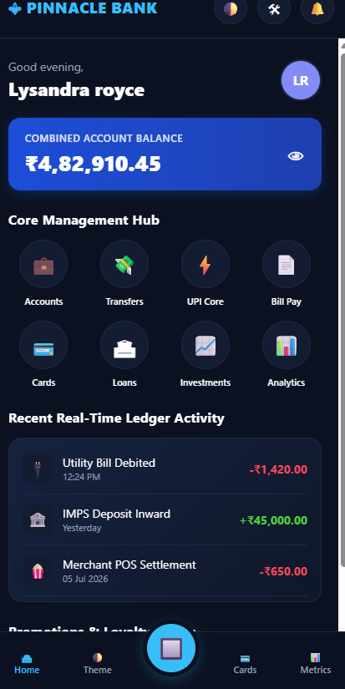
- Fund Transfer & Transaction Engine:
  - Interactive transfer orchestration module enabling internal account transfers and external beneficiary wires.
  - Real-time transaction ledger tracking itemized descriptions, categorization tags, precise timestamps, and debit/credit values.
- Digital Card & Security Management:
  - Virtual debit and credit card representation with live status controls (temporary card freeze, unfreeze, and PIN revelation toggles).
  - Account security settings allowing password updates, notification preferences, and biometric authorization triggers.
- Integrated Alert & Notification Center:
  - Chronological notification feed tracking security warnings, large deposit confirmations, low-balance alerts, and regulatory announcements.
Non-Functional Requirements Specification
- High Performance & Low Latency: Optimized single-file component architecture ensuring instantaneous page load times and zero remote network asset bottlenecks.
- Universal Responsiveness: Fluid scaling across ultra-wide desktop viewports down to mobile smartphones, ensuring zero feature degradation on touch screens.
- Security Resilience: Strict form input sanitization, simulation of encrypted session tokens, and visual indicators of secure socket transport protocols.
4. Functional Specification & Module Matrix
Module Name | System Identifier | Core Operational Behavior & User Workflow
Authentication Gateway | #login-screen | Intercepts user credential submissions, validates security tokens, and triggers view-state transition to the secure banking dashboard.
Navigation Sidebar | .sidebar | Manages single-page navigation across Dashboard, Accounts, Transfers, Transactions, Cards, and System Settings.
Financial Summary Grid | .accounts-grid | Dynamically updates and displays high-level financial metrics, total available liquid assets, and account tier distributions.
Transfer Workspace | #transfer-modal | Orchestrates internal and external money movements, validates available ledger balances, and executes instant UI updates.
Theme & Layout Controller | toggleThemeMode() | Modifies global root Document Object Model (DOM) classes to swap between high-visibility light themes and professional dark banking views.
5. System Architecture & Design Patterns
The platform is constructed around a robust client-side architecture designed for maximum portability and deterministic execution:
Plaintext
[ Browser Client Execution Environment ]
├── Semantic DOM Markup Layer (Banking Layouts, Forms, Modals)
├── Presentation Styling Engine (CSS Custom Properties, Grid/Flexbox Layouts)
└── State & Event Runtime (Session Handlers, Transaction Simulators, View Switchers)
Architectural Highlights:
- Single-Page View Swapping: Eliminates full-page reloads by employing lightweight view-switching controllers that toggle display properties across isolated functional panels.
- Runtime State Preservation: Maintains active user session attributes, account balances, and dynamic transaction arrays directly in volatile browser memory for lightning-fast responsiveness.
- Responsive Multi-Tier Layout Engine: Combines flexible CSS Grid definitions with media query breakpoints to transform multi-column desktop dashboards into stacked mobile interfaces automatically.
6. Software Design & Component Hierarchy
Structural Component Tree
Plaintext
index.html
├── #login-screen (Secure Banking Login Portal)
│ └── .login-card (Account ID, PIN, & Authentication Form)
└── #dashboard-screen (Main Banking Workspace)
├── aside.sidebar (Navigation Drawer & Account Links)
└── main.main-wrapper (Content Area)
├── header.top-header (Header Actions, Notifications, User Profile Badge)
└── section.content-body
├── #panel-overview (Account Balances & Quick Actions Grid)
└── .sub-panel-view (Dynamic Modules: Transfers, Cards, History)
UI Design System & Color Tokenization
The visual language of Pinnacle Bank is engineered to communicate institutional trust, financial stability, and operational precision:
- Primary Financial Palette: Deep authoritative navy blues (#0b2545, #133966) serving as foundational structural tones to evoke security.
- Accent & Success Indicators: Vibrant emerald greens (#2f855a, #10b981) highlighting positive asset growth, credit balances, and successful transaction receipts.
- Warning & Neutral Tones: Soft crimson highlights (#e05252) reserved for security alerts and debit metrics, paired with slate grays (#64748b) for secondary typography.
7. Data Schema & State Entity Dictionary
To facilitate rapid simulation and clear documentation, the system maps logically to a structured relational banking data architecture:
1. User Profile Entity (User)
- customer_id (String): Unique institutional banking reference key (e.g., #PB-90412).
- full_name (String): Legal name of the account holder.
- tier_status (Enumeration): Standard | Premium | Private Wealth.
- profile_avatar (URL/String): Path reference to the user profile graphic.
2. Bank Account Entity (Account)
- account_number (String): Masked ledger reference string (e.g., •••• 4092).
- account_type (Enumeration): Checking | Savings | Commercial Line | Investment.
- current_balance (Float): Real-time monetary balance value.
- currency_symbol (String): Local currency denotation indicator ($, €, £).
3. Transaction Ledger Entity (Transaction)
- transaction_id (String): Unique alphanumeric audit hash key.
- merchant_or_recipient (String): Entity name associated with the debit or credit event.
- category (Enumeration): Transfer | Groceries | Utilities | Payroll | Shopping | Investment.
- amount (Float): Monetary value (positive integers indicate deposits, negative indicate withdrawals).
- timestamp (DateTime): Precise execution date and time stamp.
8. Quality Assurance, Testing, & Verification Strategy
To guarantee absolute mathematical precision in financial calculations and uncompromised interface stability, quality assurance follows a multi-phase verification protocol:
- Cross-Browser Financial Rendering Validation: Rigorously tested across leading web browser engines (Google Chrome, Mozilla Firefox, Apple Safari, Microsoft Edge) to verify consistent font metrics, currency symbol placement, and table alignment.
- Responsive Breakpoint Stress Testing: Evaluated across distinct mobile, tablet, and widescreen viewports to ensure touch targets, modal overlays, and financial summary cards scale gracefully without text truncation.
- State Integrity & Transaction Logic Auditing: Validated login authentication sequences, real-time balance subtraction/addition accuracy during simulated transfers, and modal toggle responsiveness to ensure zero runtime exceptions.
9. Implementation Roadmap & Technology Stack
The engineering lifecycle of Pinnacle Bank relies on clean, high-performance web standards without unnecessary external dependencies:
- HTML5: Delivers semantic structural framing for secure login portals, financial tables, and interactive modal dialogs.
- CSS3: Provides an enterprise-grade visual aesthetic utilizing modern layout tools (CSS Grid and Flexbox), design tokens, and smooth transition animations.
- Vanilla JavaScript: Powers core application logic—including authentication handling, state management, transaction filtering, and dynamic DOM rendering—ensuring instantaneous execution speeds and minimal memory footprints.

